**Conditional statement:**

**1: Check Positive, Negative, or Zero:**

num = float(input("Enter a number: "))

if num > 0:

print("Positive number")

elif num < 0:

print("Negative number")

else:

print("Zero")

**output:**

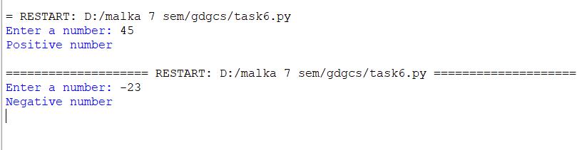

**2: Voting Eligibility Checker:**

age = int(input("Enter your age: "))

if age >= 18:

print("You are eligible to vote.")

else:

print("You are not eligible to vote yet.")

**output:**



**3: Largest of Three Numbers:**

# Taking three numbers as input

num1 = float(input("Enter first number: "))

num2 = float(input("Enter second number: "))

num3 = float(input("Enter third number: "))

# Finding the largest number

if num1 >= num2 and num1 >= num3:

largest = num1

elif num2 >= num1 and num2 >= num3:

largest = num2

else:

largest = num3

# Printing the result

print(f"Largest number is: {largest}")

**output:**

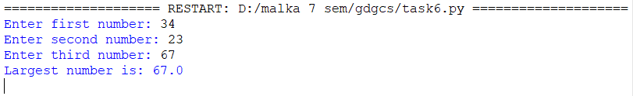

**4: Even or Odd Number Checker:**

# Taking input from the user

num = int(input("Enter a number: "))

# Checking if the number is even or odd

if num % 2 == 0:

print("Even number")

else:

print("Odd number")

**output:**

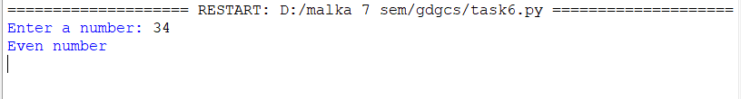

**5: Leap Year Checker:**

# Taking year input from user

year = int(input("Enter a year: "))

# Checking leap year conditions

if (year % 4 == 0 and year % 100 != 0) or (year % 400 == 0):

print(f"{year} is a Leap Year")

else:

print(f"{year} is not a Leap Year")

**output:**

**Lists:**

**6: Sum and Average of a List:**

# Creating an empty list to store numbers

numbers = []

# Asking user to enter 5 numbers

for i in range(5):

num = float(input(f"Enter number {i+1}: ")) # Taking input as float

numbers.append(num) # Adding number to the list

# Calculating sum and average

total_sum = sum(numbers)

average = total_sum / len(numbers)

# Printing the results

print("Numbers:", numbers)

print("Sum:", total_sum)

print("Average:", average)

**output:**

**7: Find Maximum and Minimum in a List:**

# Creating an empty list to store numbers

numbers = []

# Asking the user to enter 5 numbers

for i in range(5):

num = float(input(f"Enter number {i+1}: ")) # Taking input as float

numbers.append(num) # Adding number to the list

# Finding the largest and smallest numbers

largest = max(numbers)

smallest = min(numbers)

# Printing results

print("Numbers:", numbers)

print("Largest Number:", largest)

print("Smallest Number:", smallest)

**output:**

**8: Count Positive and Negative Numbers in a List:**

# Creating an empty list to store numbers

numbers = []

# Asking user to enter 10 numbers

for i in range(10):

num = int(input(f"Enter number {i+1}: ")) # Taking input as integer

numbers.append(num) # Adding number to the list

# Initializing counters for positive and negative numbers

positive_count = 0

negative_count = 0

# Counting positive and negative numbers

for num in numbers:

if num > 0:

positive_count += 1

elif num < 0:

negative_count += 1

# Printing results

print("Numbers:", numbers)

print("Positive numbers:", positive_count)

print("Negative numbers:", negative_count)

**output:**

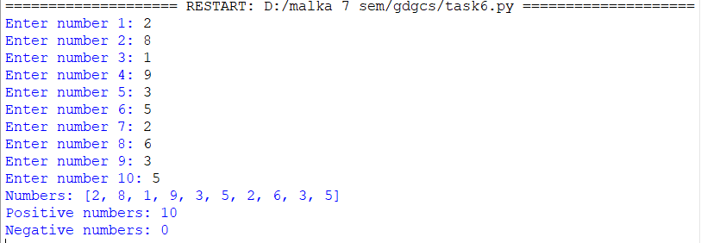

**9: Check if a Number is in the List:**

# Creating an empty list to store numbers

numbers = []

# Asking user to enter 5 numbers

for i in range(5):

num = int(input(f"Enter number {i+1}: ")) # Taking input as integer

numbers.append(num) # Adding number to the list

# Asking the user for a number to search

search_num = int(input("Enter a number to search: "))

# Checking if the number is in the list

if search_num in numbers:

print(f"{search_num} is present in the list.")

else:

print(f"{search_num} is not present in the list.")

**output:**

**10: Remove Duplicates from a List:**

# Creating an empty list to store numbers

numbers = []

# Asking user to enter 10 numbers

for i in range(10):

num = int(input(f"Enter number {i+1}: ")) # Taking input as integer

numbers.append(num) # Adding number to the list

# Removing duplicates using set and converting back to list

unique_numbers = list(set(numbers))

# Printing results

print("Original List:", numbers)

print("List after removing duplicates:", unique_numbers)

**output:**

